Express:
- Creating API
- its is framework work behind the Node.js and makes with nodeJs easier by providing some reusable classes and methods.
- Npm install express
- npm install nodemon – auto compilation and re-run application.
- DevDependacies:
  - functionality of our application is does not depend on that package.
  - Which is used to speed up our developemtn process.
- Run the file on cmd:
  - npx nodemon server.js

Creating and using Environment variable:
- npm install dotenv
- https://github.com/ukirdemonika/QuickChat_MERN_Project/commit/22f09caff078b3b96a4ccd8e5815c21c7d72010b

Download and install mongoDB Compass:
- we are using mongoDB db hosted on cloud using ATLAS .
- ATLAS is a cloud service provided by mnogoDB company for hosting mongoDB DB on cloud and we can access this anywhere in the world.
- So for manipulate and connect the data to cloude we need interface on our local machine i.e compass.
- Download and install mongoDb compass.
  - https://www.mongodb.com/try/download/compass
  - select msi file
  - after installation when we open compass in our machine, we see connection string.
  - So once we create DB on cloud we get connection string , so we copy that string and paste in out local machine connection string textbox.
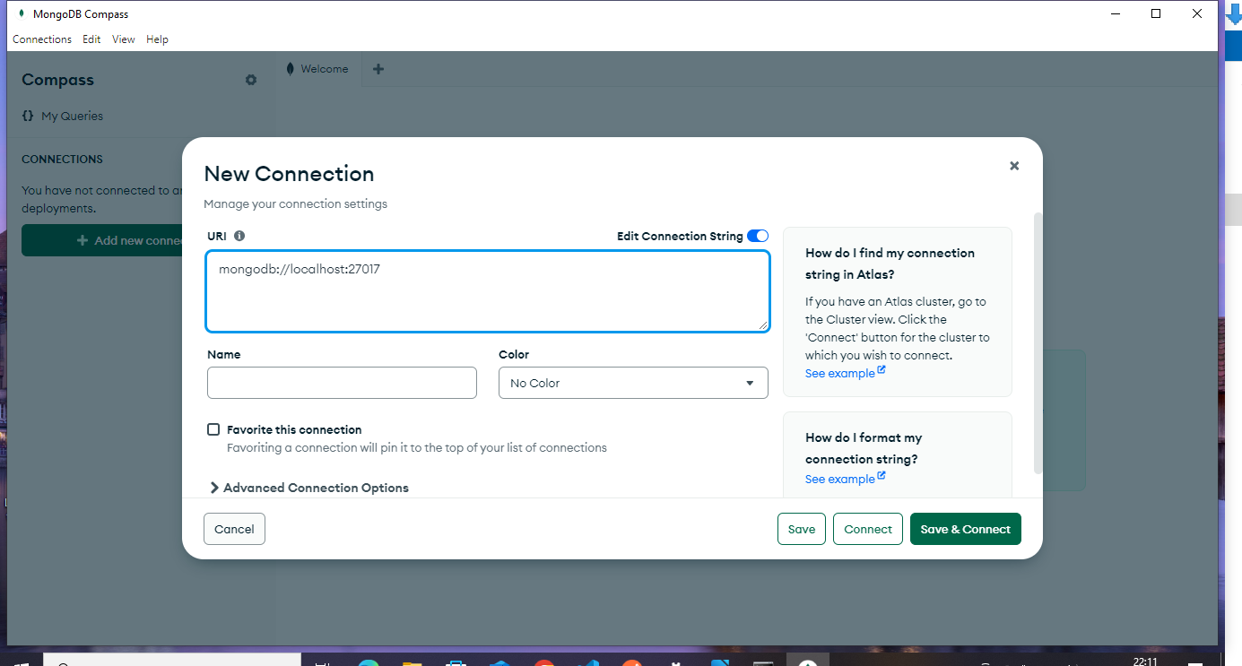

Creating mongoDb database using Atlas:
- https://www.mongodb.com/atlas
- Atlas is DB as service Provider.
- Create Atlas account--> try free
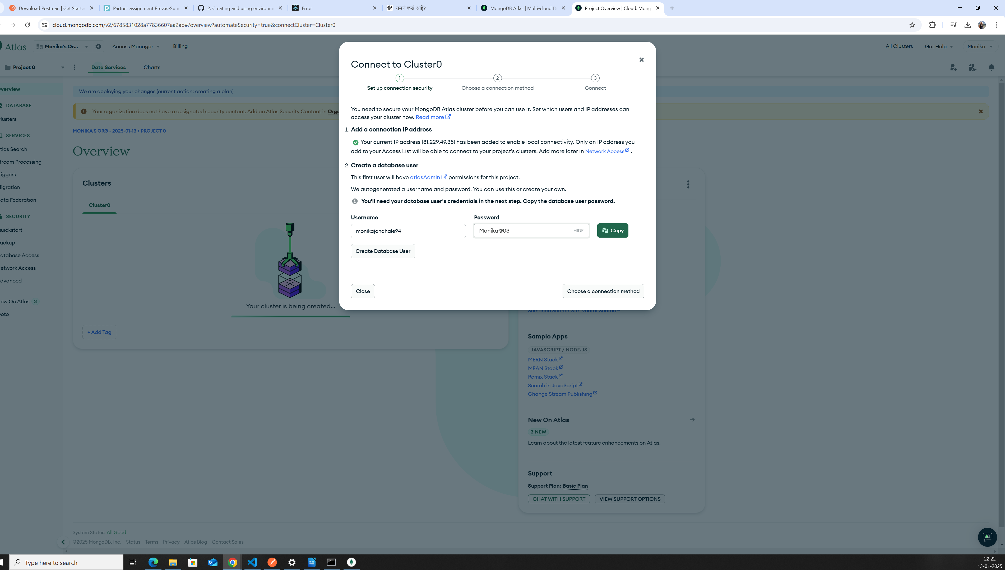
- DB created on Atlas cluster.
  - https://cloud.mongodb.com/v2/6785831028a77836607aa2ab#/metrics/replicaSet/678584638c7e3c04041c1a8a/explorer/quickChat/users/find
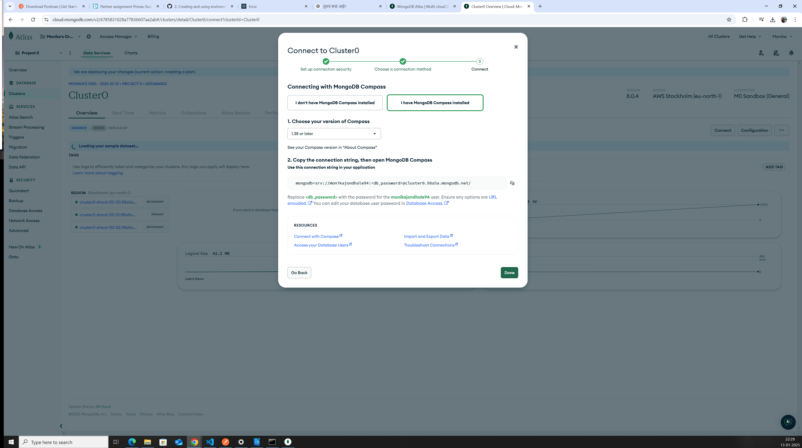
  - here is connection string , copy it.

Create user:
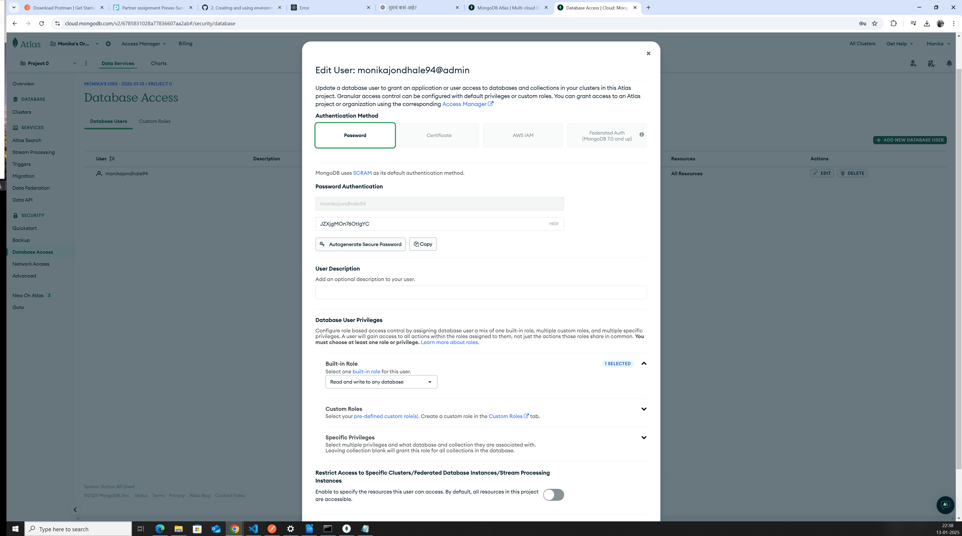

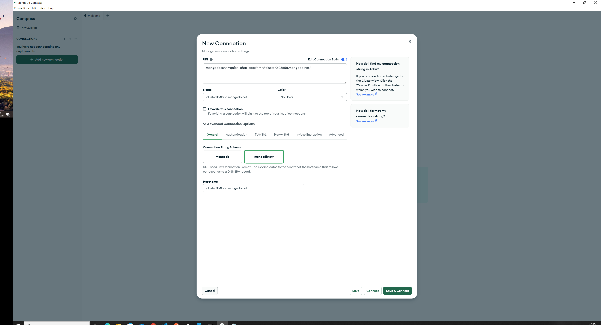
place connection string in our local machine compass and connect.
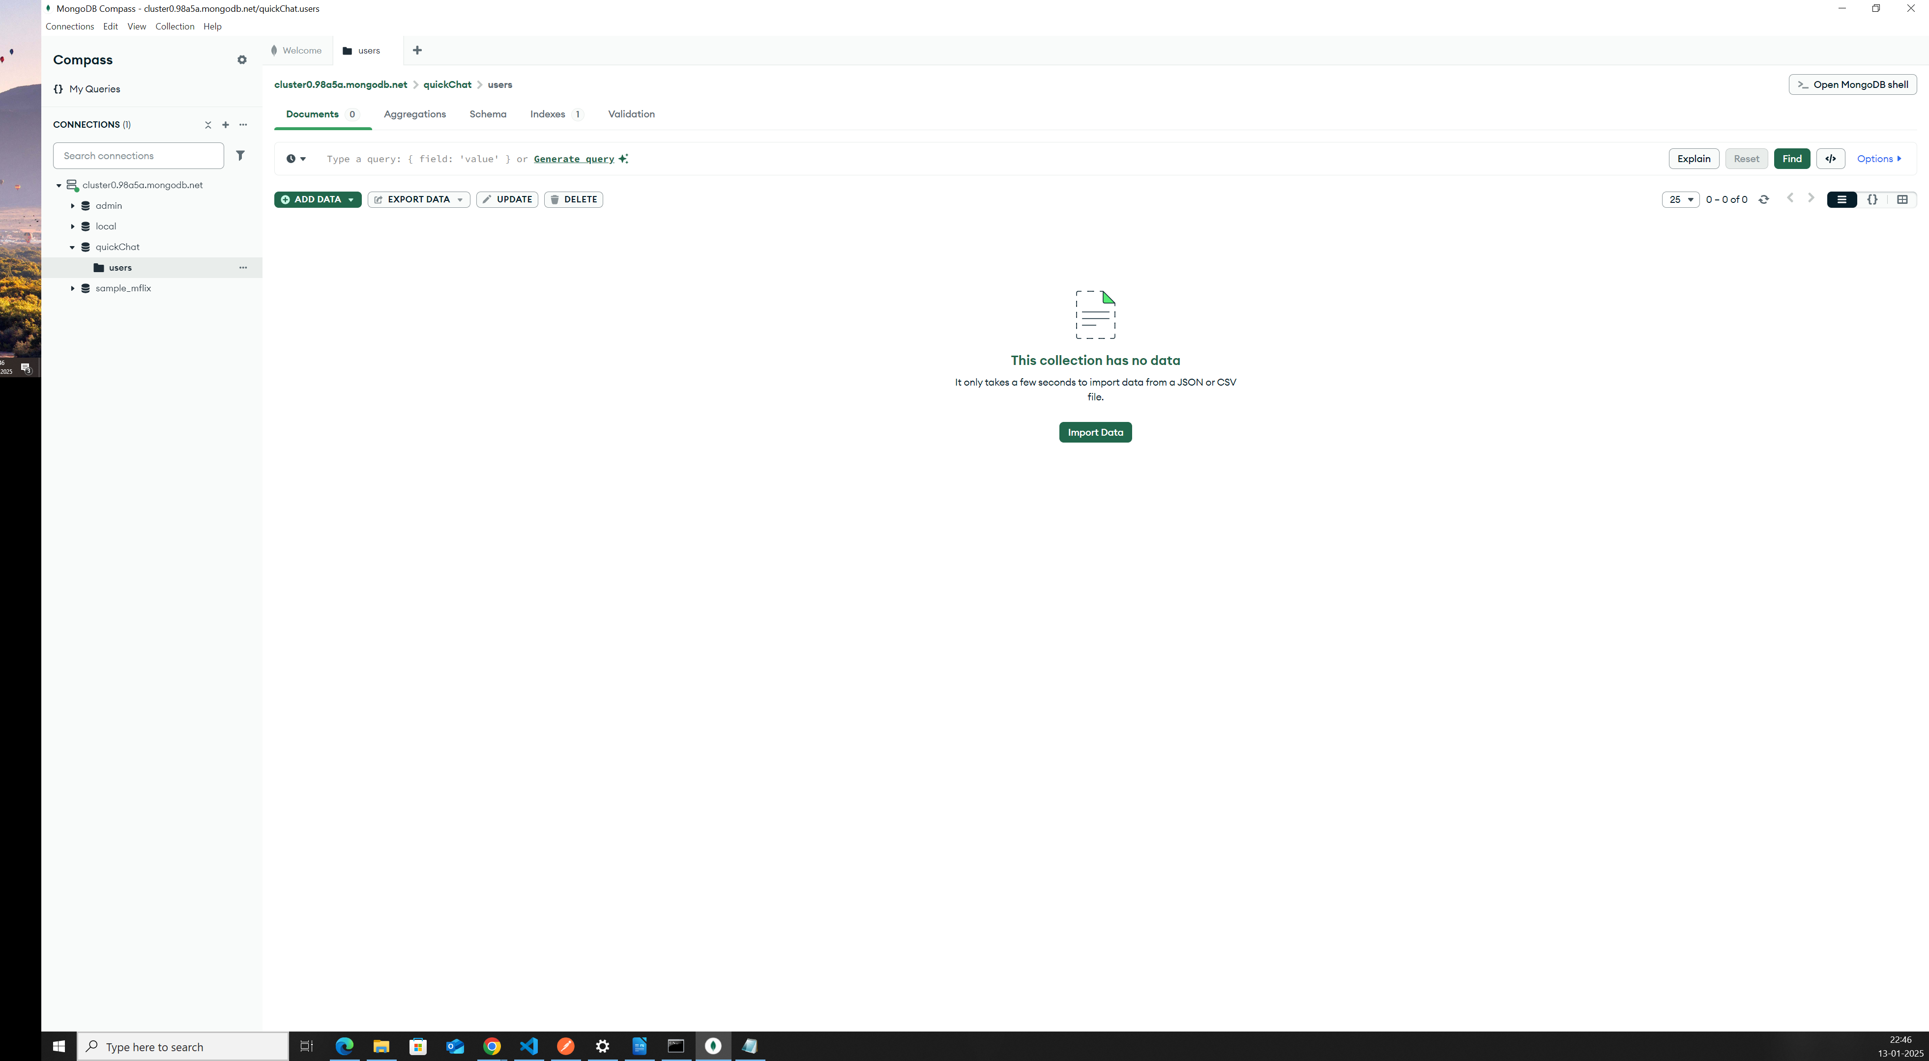
  - Now we connect local mongoDB compass to Atlas mongoDb.

Connecting Express to mongoDB Db:
- npm install mongoose
  - to connect express with mongoDB
  - mongoose are allowed to connect mongoDb Db and create ,allow the mongoDb connect from Node.js application.

